Spring Container: BeanFactory & ApplicationContext

Recap: Where We Are So Far
So far, we’ve understood:
- Dependency Injection removes object creation from classes
- Inversion of Control shifts responsibility to Spring
- Spring manages object creation, wiring, and lifecycle
Now we answer:
How does Spring actually do this?
The answer: Spring Container

What Is a Spring Container?
The Spring Container is the core engine of the Spring Framework.
It is responsible for:
- Creating beans
- Injecting dependencies
- Managing bean lifecycle
- Destroying beans
You provide:
- Classes (beans)
- Configuration metadata
Spring provides:
- Fully initialized, wired, managed objects

Configuration Metadata — How Spring Knows What to Do
Spring needs instructions to:
- Know which classes to instantiate
- How to inject dependencies
- What scope, lifecycle, values to apply
This instruction is called Configuration Metadata.
It can be provided using:
- XML Configuration
- Annotations
- Java-based configuration
For Day 4, we focus on XML configuration to understand fundamentals clearly.

Creating the Spring Container
Spring provides two core container interfaces:
Container | Purpose
BeanFactory | Simple applications
ApplicationContext | Enterprise applications
These are interfaces, so we use their implementation classes.

BeanFactory — Basic Container
When to Use:
- Small applications
- Memory-constrained environments
- Lazy initialization needed
Implementation Class:
XmlBeanFactory (older, but important conceptually)

Step 1: Create XML Configuration (config.xml)
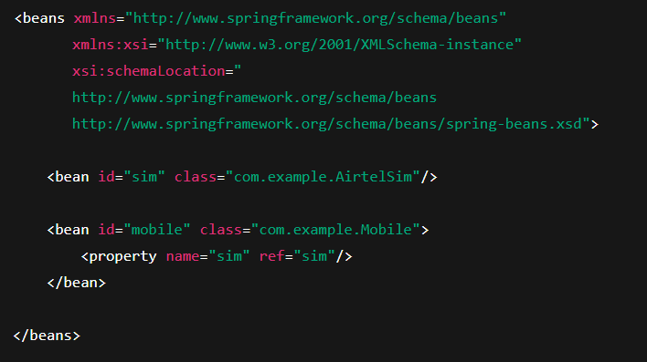

Step 2: Load XML Using Resource Interface
Spring uses Resource abstraction to load configuration.
Implementation classes:
- ClassPathResource
- FileSystemResource
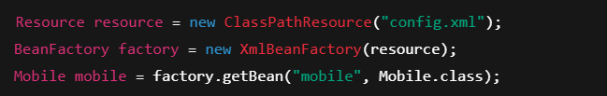
✔ Beans are created only when requested (lazy)

ApplicationContext — Enterprise Container
Why ApplicationContext Is Preferred:
- Eager initialization
- Better performance tuning
- Event handling
- Internationalization (i18n)
- AOP & integration support
Common Implementation Classes:
Class | Use Case
ClassPathXmlApplicationContext | XML inside project
FileSystemXmlApplicationContext | XML outside project
XmlWebApplicationContext | Web apps
AnnotationConfigApplicationContext | Java config
AnnotationConfigWebApplicationContext | Web + Java config

Example: ClassPathXmlApplicationContext
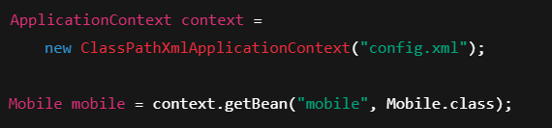
✔ Beans created at startup
✔ Faster runtime access
✔ Production-grade

Key Differences: BeanFactory vs ApplicationContext
Feature | BeanFactory | ApplicationContext
Initialization | Lazy | Eager
Performance | Slower at runtime | Faster
Enterprise features | No | Yes
Recommended | ❌ | ✅
Real projects use ApplicationContext

How Spring Uses IoC & DI Internally
- Spring Container reads configuration
- Creates objects
- Resolves dependencies
- Injects dependencies
- Manages lifecycle
Classes never call new for business components.

DI in Enterprise Layered Architecture
Spring injects dependencies across layers:
- Controller → Service
- Service → Repository
- Repository → DataSource
Each layer:
- Depends on abstraction
- Is independently testable
- Is loosely coupled

Common Interview Questions

1. “What exactly is a Spring Bean?”
Wrong answer (basic):
A Java object managed by Spring.
Correct interview answer:
A Spring Bean is a Java object whose entire lifecycle (creation, dependency injection, initialization, and destruction) is managed by the Spring Container.
Interviewers expect you to say “lifecycle”, not just “object”.

2.“What does the Spring Container really do?”
Most candidates say:
It creates objects and injects dependencies.
What interviewers expect:
- Reads configuration metadata
- Instantiates beans
- Resolves dependency graph
- Applies post-processors
- Manages full lifecycle
- Handles scope, proxying, and destruction
💡 Keyword to drop:
“Spring Container is a lifecycle and dependency orchestration engine.”

3.“DI vs IoC — what’s the real difference?”
This is a classic trap.
Correct framing:
- IoC → Principle (design philosophy)
- DI → Implementation (technique)

💡 Interview one-liner:
“IoC defines who controls, DI defines how dependencies are supplied.”

4.“Why is tight coupling bad even with ONE implementation?”
This question filters juniors from seniors.
Expected reasoning:
- Tight coupling is about control, not count
- new inside a class:
  - breaks SRP
  - blocks testability
  - forces recompilation on change
  - prevents mocking
- DI future-proofs architecture
💡 Killer line:
“Spring solves tomorrow’s change, not today’s simplicity.”

5. “Why does Spring prefer constructor injection?”
Correct senior-level reasons:
- Ensures mandatory dependencies
- Makes object immutable
- Enables fail-fast behavior
- Simplifies testing
- Prevents partially constructed objects
🚫 Wrong answers:
- “Because Spring recommends it”
- “Because it’s cleaner”

6.“What happens if I don’t use DI?”
Interviewers expect consequences, not ideology.
Correct points:
- Tight coupling
- Hard-to-test code
- Hidden dependencies
- Poor scalability
- Fragile architecture

7. “Who creates objects in Spring?”
This question leads directly to IoC.
Correct answer:
The Spring Container creates, configures, and manages objects based on configuration metadata.
If candidate says:
“Spring creates objects using new”
❌ Immediate red flag.

8.“What is configuration metadata?”
Most people fail here.
Correct answer:
Configuration metadata is instructional data that tells Spring:
- what to instantiate
- how to wire
- when to initialize
- how to destroy
Formats:
- XML
- Annotations
- Java Configuration

9.“Is Spring Container the same as JVM?”
Very common trick question.
Correct answer:
- JVM manages memory
- Spring Container manages objects
- Spring runs inside JVM
💡 Say:
“JVM manages memory, Spring manages relationships.”

10. “Why ApplicationContext over BeanFactory?”
Interviewers don’t want the table — they want reasoning.
Correct explanation:
- ApplicationContext eagerly loads beans
- Faster runtime access
- Better enterprise support
- AOP, events, i18n, lifecycle callbacks
💡 Line to remember:
“BeanFactory is minimalistic; ApplicationContext is production-grade.”

11.“Is BeanFactory used in real projects?”
Correct answer:
Rarely. ApplicationContext is the standard in enterprise applications.
But also add:
“BeanFactory concepts still matter for understanding Spring internals.”

12.“What is the Spring Container internally?”
Expected:
- Interface-based design
- Uses factory pattern
- Uses reflection
- Uses proxying (later topics)
- Maintains dependency graph

13.“Can Spring manage non-Spring classes?”
Correct answer:
Yes, as long as Spring is instructed via configuration metadata.

14. “Does Spring Boot remove IoC or DI?”
Common confusion.
Correct answer:
No. Spring Boot builds on Spring Core.
IoC, DI, and Container remain exactly the same.
💡 Add:
“Spring Boot simplifies configuration, not architecture.”

15. “What is the role of the container in testing?”
Strong interview angle.
Expected:
- Mock injection
- Test-specific configuration
- Context isolation
- Faster feedback

16. “What is NOT a Spring-managed object?”
Good trick question.
Answer:
- Objects created using new outside container
- Utility/value objects
- Simple immutable objects (BigDecimal, LocalDate)

17. When is new acceptable?
Interviewers love this nuance.
Correct answer:
Use new when:
- Object has no behavior
- No external dependency
- Immutable
- No lifecycle concern
Examples:
new BigDecimal("100");
new LocalDate();
Not acceptable for:
- Services
- Repositories
- Integrations
- Business components

18. One-Line Summary (MEMORIZE)
“Spring Core is about removing object creation, inverting control, and letting a container manage lifecycle and wiring for scalable, testable enterprise applications.”

